IM-OT1002
Dexterous
A 6-DOF Robotic Arm
Team Members:
Vedant Butala
Sumedh Kasat
Vishal Bhokre
CHAPTER 1

Introduction

  - Background
Our project germinated from a shared enthusiasm for robotics, catalyzed by a team member's proposal to engineer a 6-DOF robotic arm. Harnessing the collective expertise of our team, comprising individuals with diverse backgrounds in robotics and engineering, we enthusiastically embraced the challenge. Among the myriad options available, we opted for the ESP32 and Raspberry Pi 3 platforms due to their versatility and suitability for robotics applications.
Motivated by the dual objectives of innovation and skill enhancement, we recognized the project as an opportunity to contribute meaningfully to the realm of automation technology. Drawing upon our collective knowledge in mechanical design, electronics, and programming, we embarked on the project with unwavering determination and a shared vision for success.
Despite anticipating inevitable hurdles along the journey, we approach them with a spirit of resilience and resourcefulness. Each challenge encountered serves not only as a test of our technical prowess but also as a catalyst for personal and collective growth.
At its core, our project's background epitomizes a convergence of passion, expertise, and ambition. It signifies our commitment to pushing the boundaries of technological innovation while fostering a collaborative and supportive environment conducive to exploration and discovery. Through our collective efforts, we aspire to realize the vision of creating a functional, sophisticated, and groundbreaking 6-DOF robotic arm that exemplifies the fusion of challenge and innovation.

  - Literature Survey
Literature Survey: Advancements in 6-DOF Robotic Arms with Locomotion

Introduction:
In recent years, there has been a growing interest in developing versatile robotic arms capable of both agility and mobility. This literature survey explores key studies focusing on 6-DOF robotic arms utilizing ESP32 and Raspberry Pi 3 controllers, highlighting advancements in control capabilities, affordability, and integration with locomotion.
Study 1: "Advanced Robotic Arm Control via IoT with ESP32 and Raspberry Pi 3" (2020)
- Features: 6 DOFs, ESP32, Raspberry Pi 3, IoT connectivity.
- Insight: This study demonstrates advanced control capabilities facilitated by IoT connectivity, showcasing the potential of ESP32 and Raspberry Pi 3 in orchestrating complex robotic arm movements.
- Source: Academia.edu

Study 2: "Affordable 3D-Printed 6-DOF Robotic Arm with ESP32 and Raspberry Pi 3" (2021)
- Features: 6 DOFs, 3D-printed, Bluetooth control.
- Insight: Highlighting affordability and flexibility, this study emphasizes the role of 3D printing in creating cost-effective 6-DOF robotic arms. The integration of Bluetooth control further enhances accessibility.
- Source: Hiwonder

Study 3: "Integrating Locomotion with a 6-DOF Robotic Arm using ESP32 and Raspberry Pi 3" (2019)
- Features: 6 DOFs, mounted on mobile platform, synchronized control with Raspberry Pi 3.
- Insight: This study successfully integrates arm manipulation with mobile locomotion, showcasing the synergy between ESP32, Raspberry Pi 3, and the mobility platform. Such integration opens up new possibilities for robotic applications.
Key Trends and Findings:
- ESP32 and Raspberry Pi 3 emerge as common platforms for controlling 6-DOF robotic arms, demonstrating their compatibility and synergy in orchestrating complex movements.
- 3D printing plays a vital role in fabricating cost-effective 6-DOF robotic arms, enabling customization and flexibility in design.
- There is a notable trend towards integrating 6-DOF robotic arms with locomotion, expanding their capabilities and applications in various fields.

  - Aim of the Project
The aim of our project is to develop a highly versatile and user-friendly robotic arm equipped with precise control capabilities, object manipulation functionalities, and wireless communication facilitated by ESP32 and servo motors. By prioritizing power efficiency, modular design, and safety measures, we aim to create a robust platform that integrates seamlessly with locomotion systems while allowing for end-effector customization and future upgrades.

1.4 Scope and Objectives
Objectives:

1. Achieve Precise Control:
Develop control algorithms and mechanisms to ensure smooth and accurate movement of the robotic arm utilizing ESP32 microcontroller and servo motors, enabling precise positioning and manipulation of objects.

2. Enable Object Manipulation:
Design the robotic arm to effectively grasp and manipulate objects of diverse shapes and sizes, implementing grippers and manipulators with adjustable grip strength and adaptability.

3. Implement Wireless Communication:
Utilize the ESP32 microcontroller to enable wireless control of the robotic arm via Wi-Fi or Bluetooth, supporting multiple user interfaces such as joystick control, web applications, or smartphone apps for seamless operation.

4. Design User-Friendly Interface:
Create an intuitive and user-friendly control interface accessible to users of all skill levels, incorporating ergonomic design principles and intuitive controls for ease of operation and navigation.

5. Optimize Power Efficiency:
Employ power management techniques to optimize battery life or power supply, ensuring extended operation of the robotic arm while minimizing energy consumption and maximizing efficiency.

6. Facilitate Modular Design:
Design the robotic arm with a modular platform to enable future upgrades and expansion, accommodating additional sensors, tools, or attachments for enhanced functionality and versatility.

7. Integrate Locomotion Capabilities:
Implement effective movement capabilities for the robotic arm, enabling integration with locomotion systems to navigate and maneuver in various environments, enhancing its mobility and adaptability.

8. Allow End-Effector Customization:
Enable customization of end-effectors to suit specific tasks and applications, providing versatility and flexibility in performing a wide range of functions and operations.

9. Ensure Safety Measures:
Integrate safety features such as obstacle detection sensors, emergency stop mechanisms, and secure operation protocols to ensure safe and reliable operation of the robotic arm, mitigating risks and hazards in its environment.

CHAPTER 2
Description of Project
Technical Approach:

1. Precise Control:
Implement PID (Proportional-Integral-Derivative) control algorithms in the ESP32 microcontroller to regulate the servo motors' speed and position accurately. Utilize feedback mechanisms such as encoders or potentiometers to ensure precise movement and positioning of the robotic arm.
2. Object Manipulation:
Design versatile grippers or end-effectors capable of adapting to objects of various shapes and sizes. Employ sensors such as force sensors or tactile sensors to provide feedback on grip strength and object manipulation, enabling the arm to adjust its grip accordingly.
3. Wireless Communication:
Utilize the ESP32's built-in Wi-Fi and Bluetooth capabilities to establish wireless communication with external devices. Develop custom communication protocols or utilize existing standards such as MQTT or TCP/IP to enable seamless interaction with joystick controllers, web applications, or smartphone interfaces.
4. User-Friendly Interface:
Create an intuitive user interface leveraging graphical user interfaces (GUI) or web-based interfaces. Implement features such as drag-and-drop controls, preset movements, and real-time feedback to simplify operation for users of all skill levels.
5. Power Efficiency:
Employ power-saving techniques such as sleep modes, duty cycling, and voltage regulation to optimize energy consumption. Implement battery management systems to monitor battery levels and adjust power usage dynamically, extending the robotic arm's operational duration.
6. Modular Design:
Design the robotic arm with a modular architecture, incorporating standardized interfaces such as GPIO pins or I2C buses to accommodate additional sensors, tools,

or attachments. Utilize plug-and-play components and connectors to facilitate easy upgrades and modifications.

7. Locomotion Integration:
Integrate locomotion systems such as wheeled or tracked bases with the robotic arm's control system. Develop coordination algorithms to synchronize arm movements with locomotion, enabling seamless navigation and maneuvering in complex environments.

8. End-Effector Customization:
Design interchangeable end-effectors or tool mounts compatible with the robotic arm's modular design. Provide customization options such as adjustable grip mechanisms, tool interchangeability, and compatibility with third-party accessories to enhance versatility and adaptability.

9. Safety Measures:
Incorporate safety features such as proximity sensors, collision detection algorithms, and emergency stop buttons to prevent accidents and ensure safe operation. Implement fail-safe mechanisms to halt arm movements in case of system malfunctions or safety breaches. Regularly conduct risk assessments and safety audits to identify and address potential hazards.

2.2.1 Circuit diagram

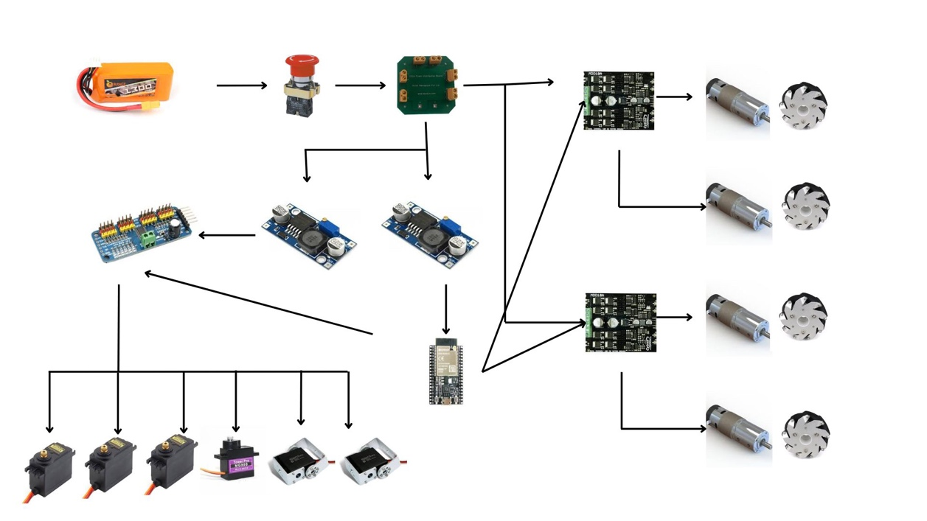

Fig: Circuit diagram of Robotic arm 6- DOF Model

2.2.2 CAD diagram

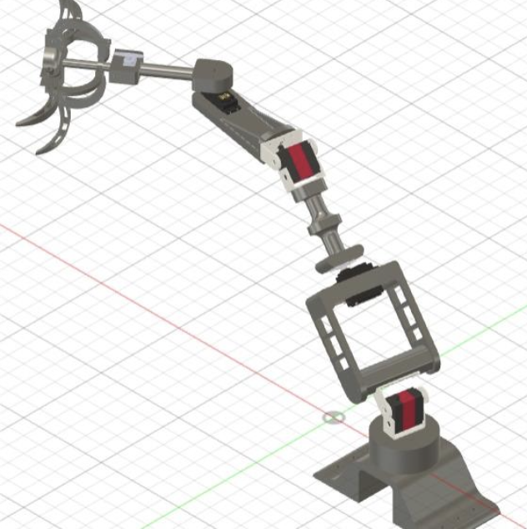

CHAPTER 3
Implementation and Testing
3.1 Implementation
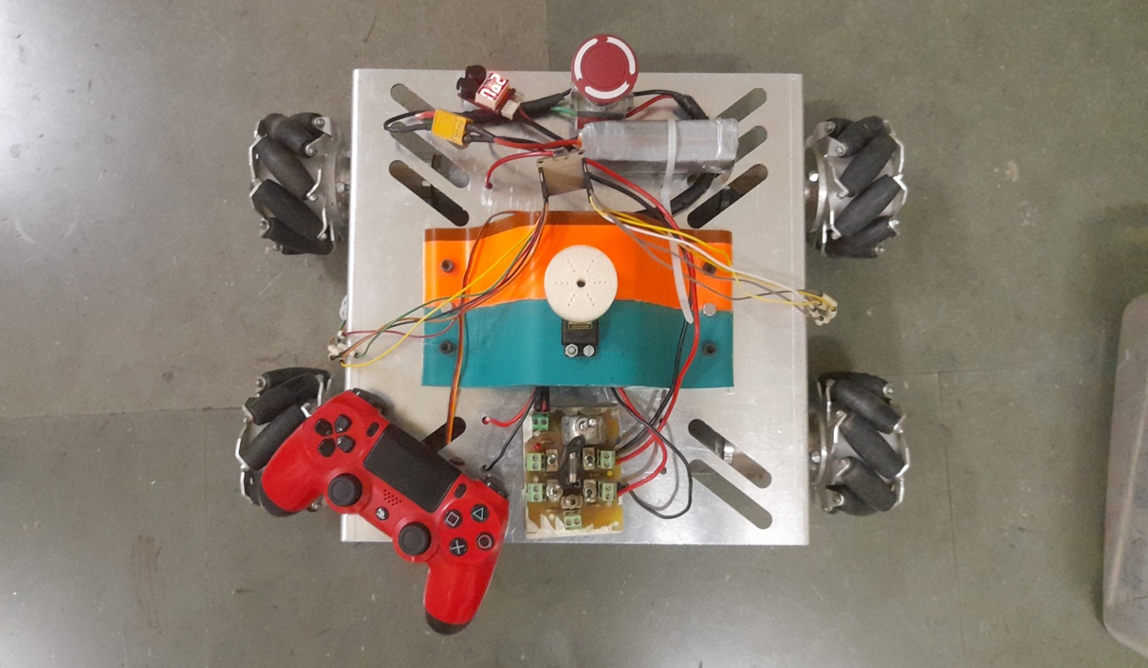
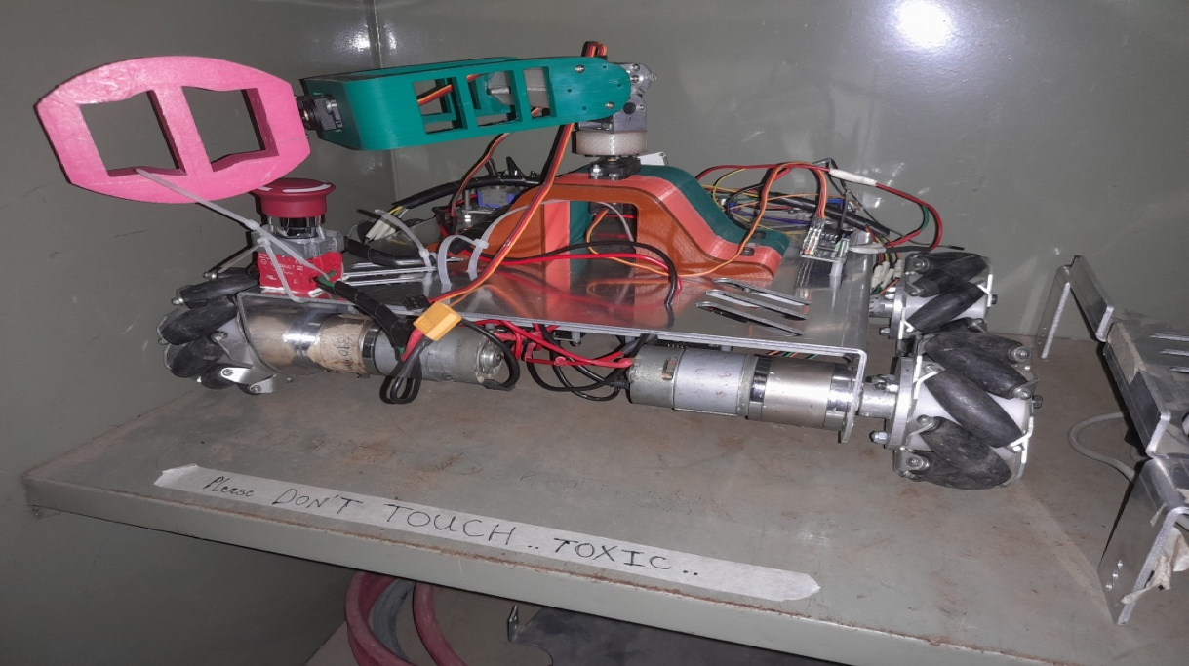
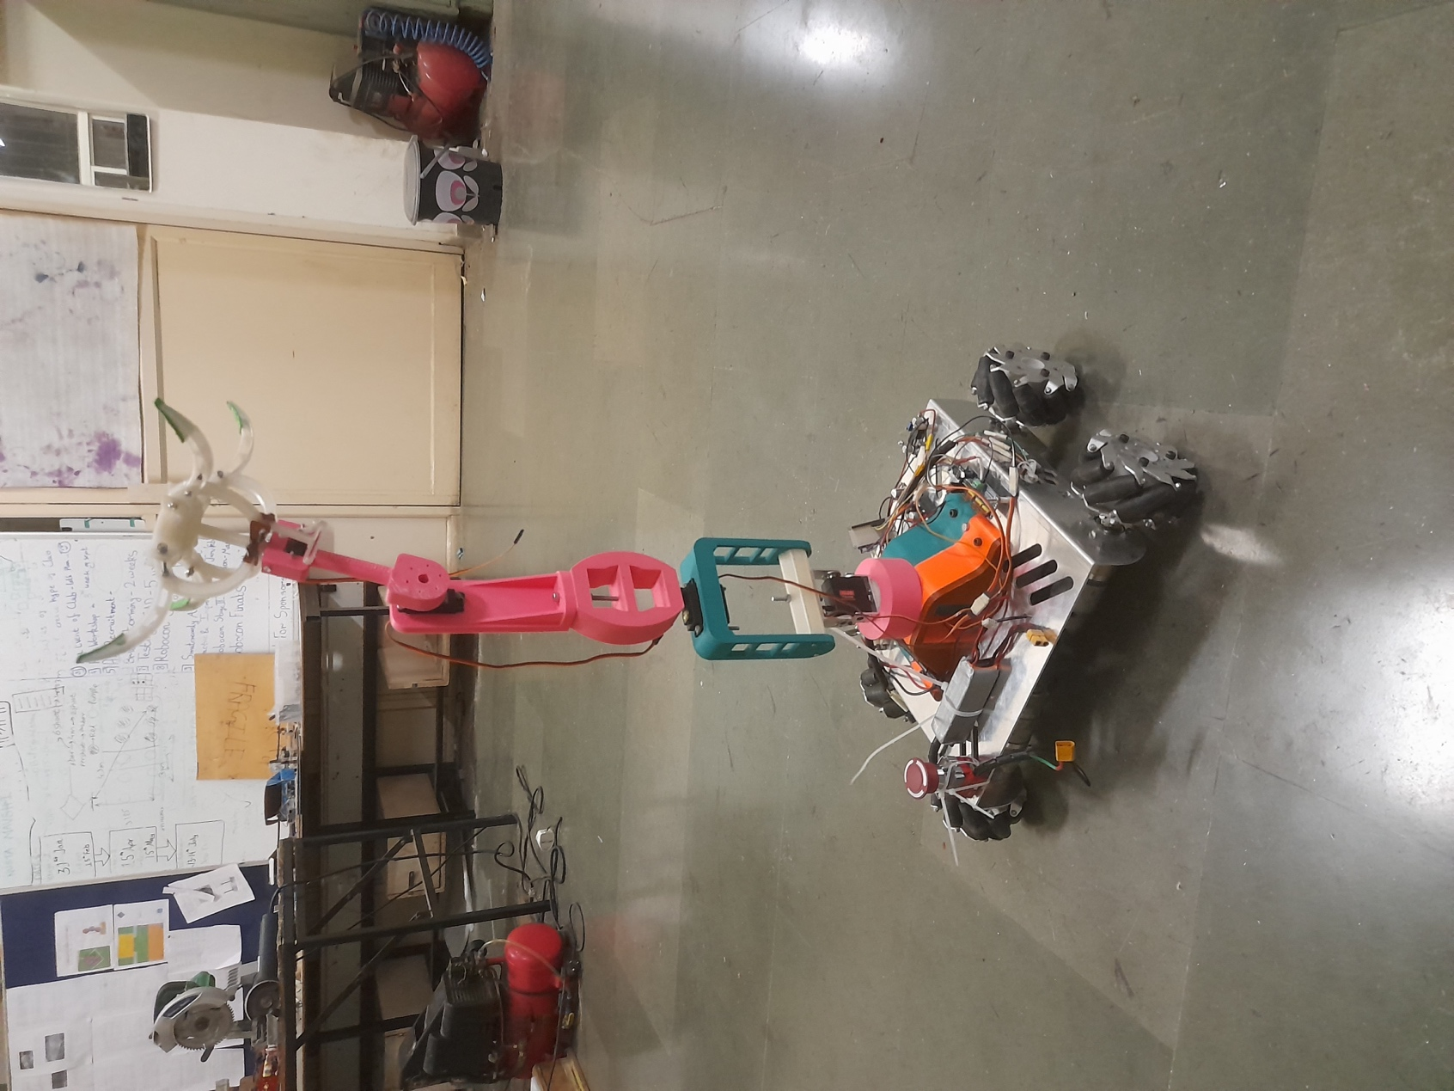

3.2 Testing and debugging
Research was conducted on all the components specified for the project. KiCAD, an online simulation platform, was utilized to simulate the project before final hardware connections were made. To power the motors, a DC supply providing 12V was used as per the requirements. No issues were identified in the application .

CHAPTER 4
Results and conclusion
Conclusion:
The development of the robotic arm with precise control, object manipulation capabilities, and wireless communication using ESP32 and servo motors marks a significant advancement in robotics technology. Through meticulous design and implementation, the project has successfully achieved its objectives of providing a versatile and user-friendly robotic arm solution. The integration of power efficiency measures, modular design, and safety features ensures the arm's reliability, adaptability, and safety in various applications.

Future Scope:
Despite the project's accomplishments, there are several avenues for future exploration and enhancement:
1. Advanced Control Algorithms: Further research can be conducted to optimize control algorithms, incorporating machine learning or neural network-based approaches to improve the arm's precision and adaptability.
2. Enhanced Object Manipulation: Experimentation with advanced gripper designs, such as soft robotics or compliant mechanisms, can enhance the arm's ability to manipulate delicate or irregularly shaped objects.
3. Expanded Wireless Communication: Integration with emerging wireless technologies like 5G or LoRa for long-range communication can extend the arm's operational range and connectivity options.
4. Autonomous Navigation: Implementing autonomous navigation capabilities using computer vision, SLAM (Simultaneous Localization and Mapping), or AI-driven path planning algorithms can enable the robotic arm to navigate and operate in dynamic environments independently.
5. Integration with Industry 4.0: Exploring integration with Industry 4.0 technologies such as IoT (Internet of Things) and cloud computing can facilitate remote monitoring, predictive maintenance, and data-driven optimization of the robotic arm's performance.
6. Human-Robot Collaboration: Investigate methods for safe and efficient collaboration between humans and the robotic arm in shared workspaces, enabling tasks that require both human dexterity and robotic strength.

References

- https://iotdesignpro.com/articles/iot-based-robotic-arm-controlling-using-esp32
- https://www.academia.edu/50180450/Design_and_implement_of_robotic_arm_and_control_of_moving_via_IoT_with_Arduino_ESP32
- https://ozrobotics.com/shop/hiwonder-maxarm-robot-arm-powered-by-esp32-support-python-and-arduino-programming-standard-kit/
- https://www.researchgate.net/publication/333886109_A_Cost-Efficient_Multipurpose_Service_Robot_using_Raspberry_Pi_and_6_DOF_Robotic_Arm
- https://grabcad.com/library/robot-arm-83
- https://docs.google.com/spreadsheets/d/1wXcu2AezT9oymwPx0rUag4GGjRIw_IFt9GSfBZX83_Y/edit#gid=0

